WannaCry Analysis Report

Entry

Open <http://www.iuqerfsodp9ifjaposdfjhgosurijfaewrwergwea.com>, if true, nothing to do, if false, Start malicious behavior in sub_408090() function.

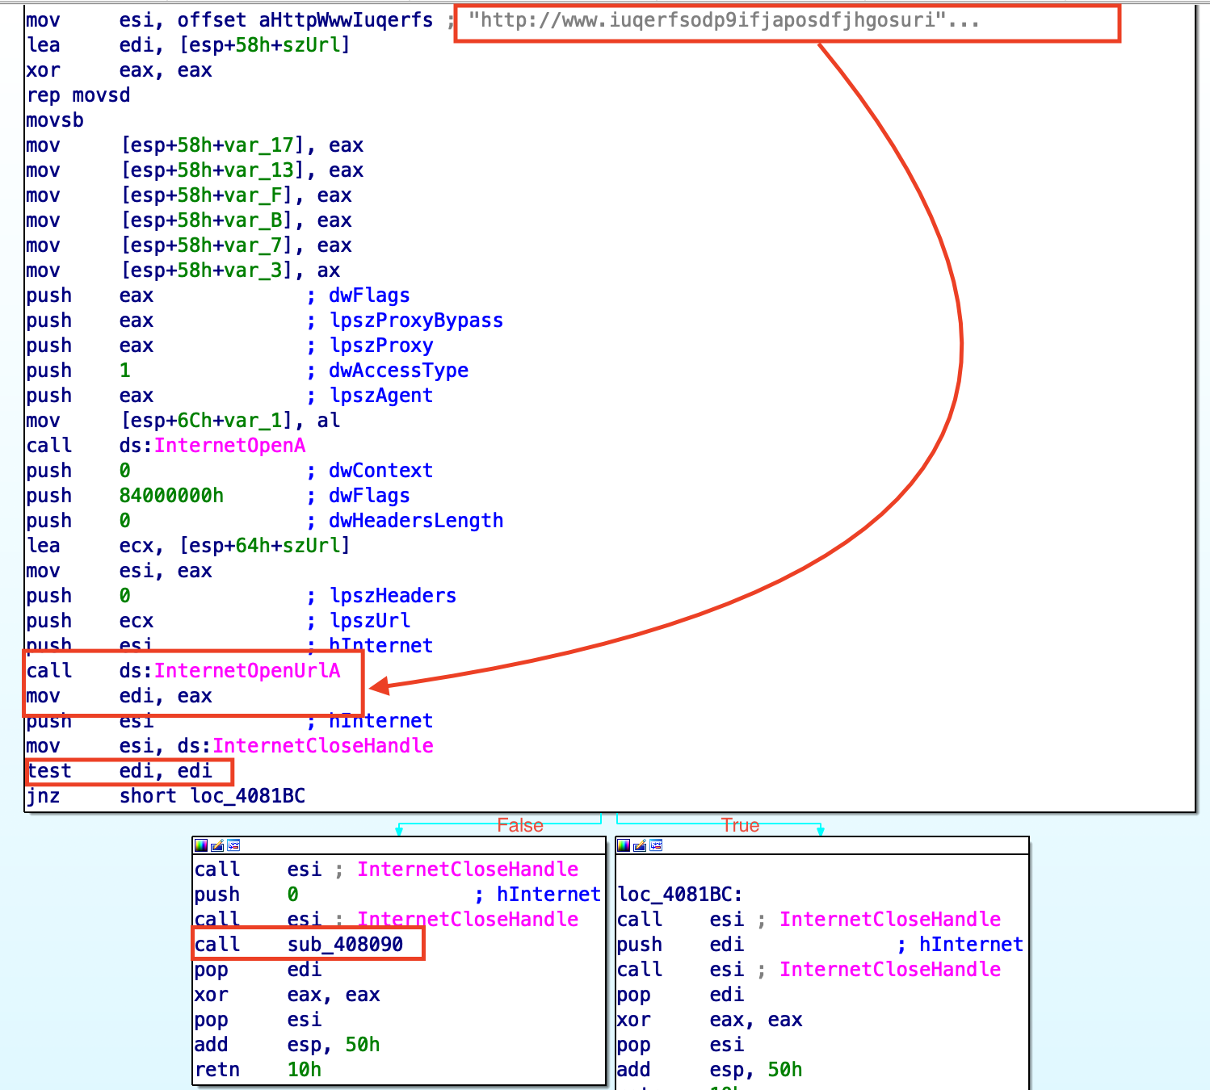

sub_408090() function

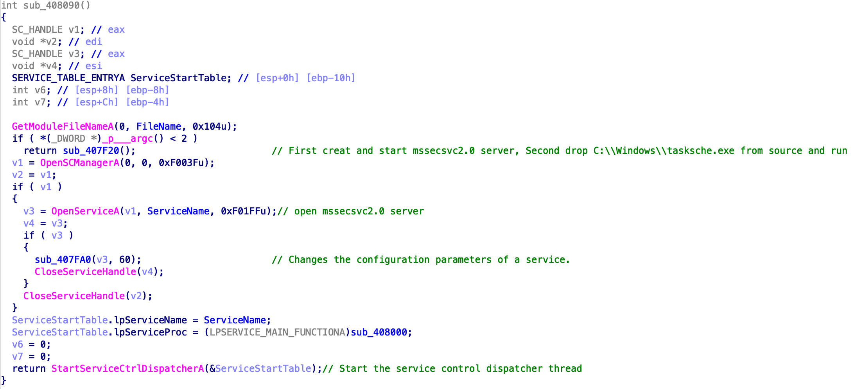

if __p___argc() > 2 :

open mssecsvc2.0 server

else:

sub_407F20()

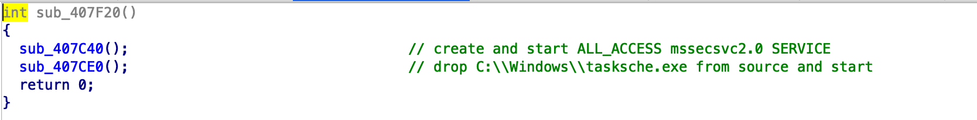

sub_407C40();

creat mssecsvc2.0 SERVICE, display name is Microsoft Security Center (2.0) Service

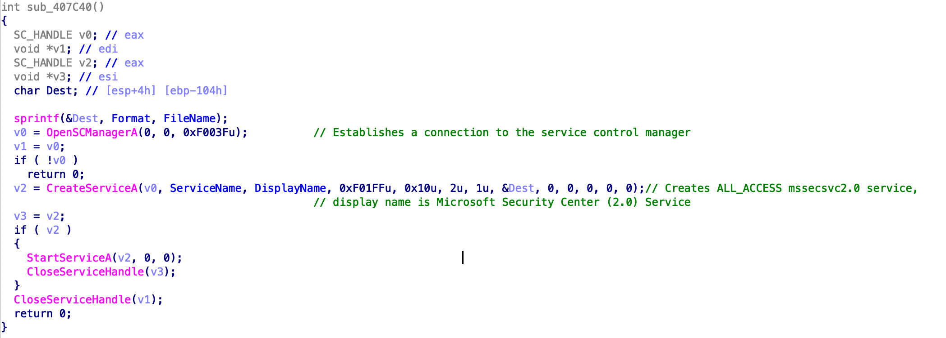

sub_407CE0();

drop taskscge.exe from source, and use args run it

